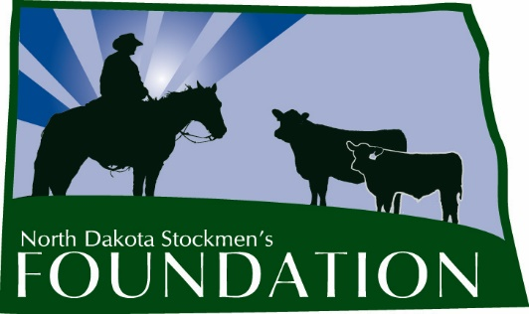

NORTH DAKOTA STOCKMEN’S FOUNDATION

TOKACH ANGUS RANCH MEMORIAL SCHOLARSHIP

NAME: The name of this scholarship is the North Dakota Stockmen’s Foundation Tokach Angus Ranch Memorial Scholarship.

PURPOSE: The purpose of this scholarship is to provide a source of financial support for a student majoring in Animal Science, Range Science, Pre-Vet, Agribusiness, Ag Communications, Farm & Ranch Management, or another beef-related discipline.

INCLUDES: The scholarship will be for $500 and will include a one-year membership in the North Dakota Stockmen’s Association.

ELIGIBILITY: Students eligible for this scholarship will:
1. Be residents of North Dakota.
2. Have a grade point average of at least 3.0.
3. At the time of application, be enrolled in an institution of higher education in a discipline listed above.
4. Have an interest in the state's beef cattle industry.
5. Be a member or a child of a member of the North Dakota Stockmen’s Association.
6. Submit the required application form, essay, transcript and references. Emailed applications will not be accepted.

The scholarship is based primarily on need and a desire for higher education, with scholastic achievement, leadership, extra-curricular activities and moral character being secondary concerns. Preference will be given to students who have completed their bachelor's degree and who are pursuing a graduate education or professional school (i.e. veterinary or law school).

MANNER AND TIME OF CHOICE: The deadline to submit applications to the North Dakota Stockmen’s Association office is March 1. The scholarship committee will make the final selection. Payment will be made following enrollment in the fall semester.

FUNDING: Upon selection of the recipient, the North Dakota Stockmen’s Foundation will forward a check for the amount of the award to the college or university development foundation. The Foundation will make the scholarship payment upon authorization by the office of student financial aid.

GUIDELINES: 1. The Scholarship Selection Committee will be made up of the NDSF advisory committee chairman and at least three other livestock industry professionals.

2. Any changes deemed necessary must be made by the North Dakota Stockmen’s Foundation Board of Directors.

3. The winner should be published in the North Dakota Stockman and other publications and if possible, be recognized at the annual convention in order to give the winner and the North Dakota Stockmen’s Foundation as much positive publicity as possible.

4. The scholarship selection should include these criteria:
a. Need.
b. Application form.
c. Interest in the beef industry.

5. Application will include:
a. A description of the applicant’s involvement in the cattle industry (activities, organizations, awards, etc.)
b. Why the applicant chose his or her current major.
c. What the applicant sees for the future of the cattle industry.
d. What the applicant’s plans are involving the cattle industry following graduation.
TOKACH ANGUS RANCH MEMORIAL SCHOLARSHIP

First Name: Middle Initial: Last Name:
Home Address:
Current Grade: School Address:
Home Phone: Cell Phone: School Phone:
Parent's Name & Address:
Birthdate: High School GPA: College GPA:
Major/Minor:
Reason for applying for scholarship:
Other scholarships you have received and the dollar amounts of the scholarships:
Why did you choose your current major?
What are your plans involving the cattle industry following graduation?
Describe your involvement in the cattle industry (activities, organizations, awards, etc.):
ON A SEPARATE SHEET: What is an issue North Dakota cattle producers are facing and how can you help producers address this issue?
Provide two letters of reference and transcript (must be included with application).
Signature:

Completed application should be submitted by March 1 to:

Tokach Angus Ranch Memorial Scholarship
c/o North Dakota Stockmen's Association
407 S. 2nd St.
Bismarck, ND 58504

