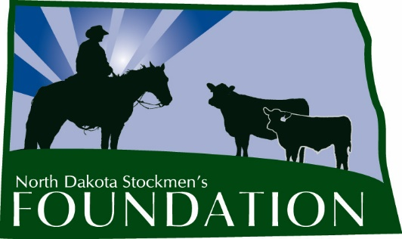

NORTH DAKOTA STOCKMEN’S FOUNDATION

MYRON WOLD MEMORIAL SCHOLARSHIP

NAME: The name of this scholarship is the North Dakota Stockmen’s Foundation Myron Wold Memorial Scholarship.

PURPOSE: The purpose of this scholarship is to provide financial support to students preparing to study an agricultural major and to honor the memory of the late Myron Wold of Watford City, N.D., who left a positive mark on the North Dakota beef industry. Myron was a well-known Red Angus breeder who was a member of the North Dakota Stockmen's Association for many years. Myron had a deep passion for all things farming and ranching.

INCLUDES: Two $1,000 scholarships will be given. Scholarship recipients will also receive a complimentary one-year student membership in the North Dakota Stockmen’s Association.

ELIGIBILITY: Students eligible for this scholarship will:
1. Be residents of North Dakota.
2. Have a grade point average of at least 3.0.
3. At the time of application, be a high school senior.
4. Have an interest in the state’s beef cattle industry.
5. Be a member or a child of a member of the North Dakota Stockmen’s Association.
6. Be planning to major in an agriculturally related discipline at any accredited college or university.
7. Submit the required application form, essay, transcript and references. Emailed applications will not be accepted.

The scholarship is based primarily on need and a desire for higher education, with scholastic achievement, leadership and extracurricular activities being secondary priorities.

MANNER AND TIME OF CHOICE:
The deadline to submit applications to the North Dakota Stockmen’s Association office is March 1. The scholarship committee will make the final selection. Payment will be made following enrollment in the fall semester.

FUNDING: Upon selection of the recipient, the North Dakota Stockmen’s Foundation will forward a check for the amount of the award to the college or university development foundation. The Foundation will make the scholarship payment upon authorization by the office of student financial aid.

GUIDELINES: 1. The Scholarship Selection Committee will be made up of the North Dakota Stockmen’s Foundation president and at least three other livestock industry professionals.

2. Any changes deemed necessary must be made by the North Dakota Stockmen’s Foundation Board of Directors.

3. The winner will be published in the North Dakota Stockman and other publications and, if possible, be recognized at the annual convention in order to give the winner and the North Dakota Stockmen’s Foundation as much positive publicity as possible.

4. Application will include:
a. A description of the applicant’s involvement in the cattle industry (activities, organizations, awards, etc.)
b. Why the applicant chose his or her current major.
c. What the applicant sees for the future of the cattle industry.
d. What the applicant’s plans are involving the cattle industry following graduation.

MYRON WOLD MEMORIAL SCHOLARSHIP

First Name: Click or tap here to enter text. Middle Initial: Click or tap here to enter text. Last Name: Click or tap here to enter text.
Home Address: Click or tap here to enter text.
Current Grade: Click or tap here to enter text. School Address: Click or tap here to enter text.
Home Phone: Click or tap here to enter text. Cell Phone:Click or tap here to enter text. School Phone: Click or tap here to enter text.
Parent's Name & Address: Click or tap here to enter text.
Birthdate: Click or tap here to enter text. High School GPA:Click or tap here to enter text. College GPA: Click or tap here to enter text.
Major/Minor: Click or tap here to enter text.
Reason for applying for scholarship: Click or tap here to enter text.

Why did you choose your current major? Click or tap here to enter text.
What are your plans involving the cattle industry following graduation? Click or tap here to enter text.
Describe your involvement in the cattle industry (activities, organizations, awards, etc.): Click or tap here to enter text.
ON A SEPARATE SHEET: Discuss an issue that is important to North Dakota cattle producers.
Provide two letters of reference and transcript (must be included with application).
Signature:

Completed application should be submitted by March 1 to:

Myron Wold Memorial Scholarship
c/o North Dakota Stockmen’s Association
407 South 2nd Street
Bismarck, ND 58504

